Sire Audit Reporting Module
A Quick Guide

1. Sire Audit Reports

These reports will display the data related to the Sire Audit. There are 13 reports in this module divided into 4 sections.
To Navigate to this module login into BI instance using the below url.
http://192.168.166.203:9704/analytics/saw.dll?bieehome&startPage=1

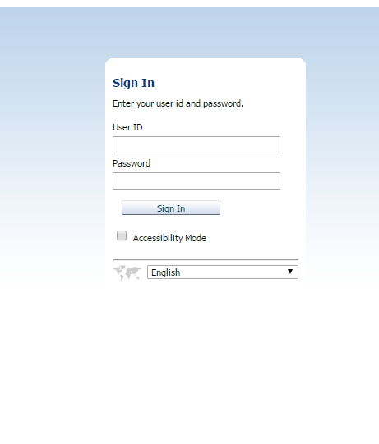

Enter the below Credentials
User ID : Operations
Password : welcome1

Once Logged in then navigate to the dashboards and select Navigation Audit Dashboard

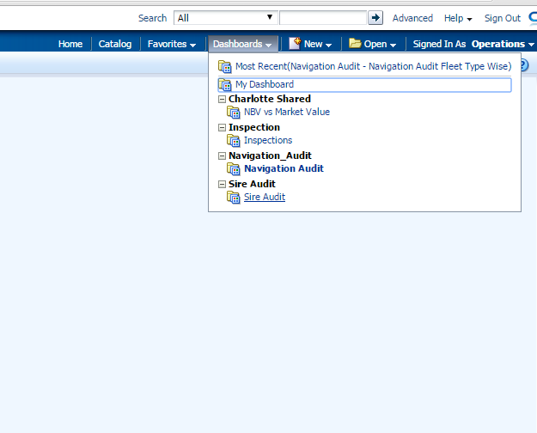

- Once logged in then click on the URL to navigate to the required report.
    - There are few Parameters for the each report. They are
        - Audit Dates : These are the Date ranges within which the data needs to be displayed
        - Category : Select Master for Master’s Audit information and select Office for Office Audit information.
        - Fleet Type : Select different Fleet types like Fleet A,Fleet B,Fleet C
        - Exclude-UK : Select Yes if the report should not display information related the Vessels handled by EPS UK.
        - Year : Select the particular year for which the data to be displayed.
As shown below:

